Monday 11th May 2020
Hello year 2,
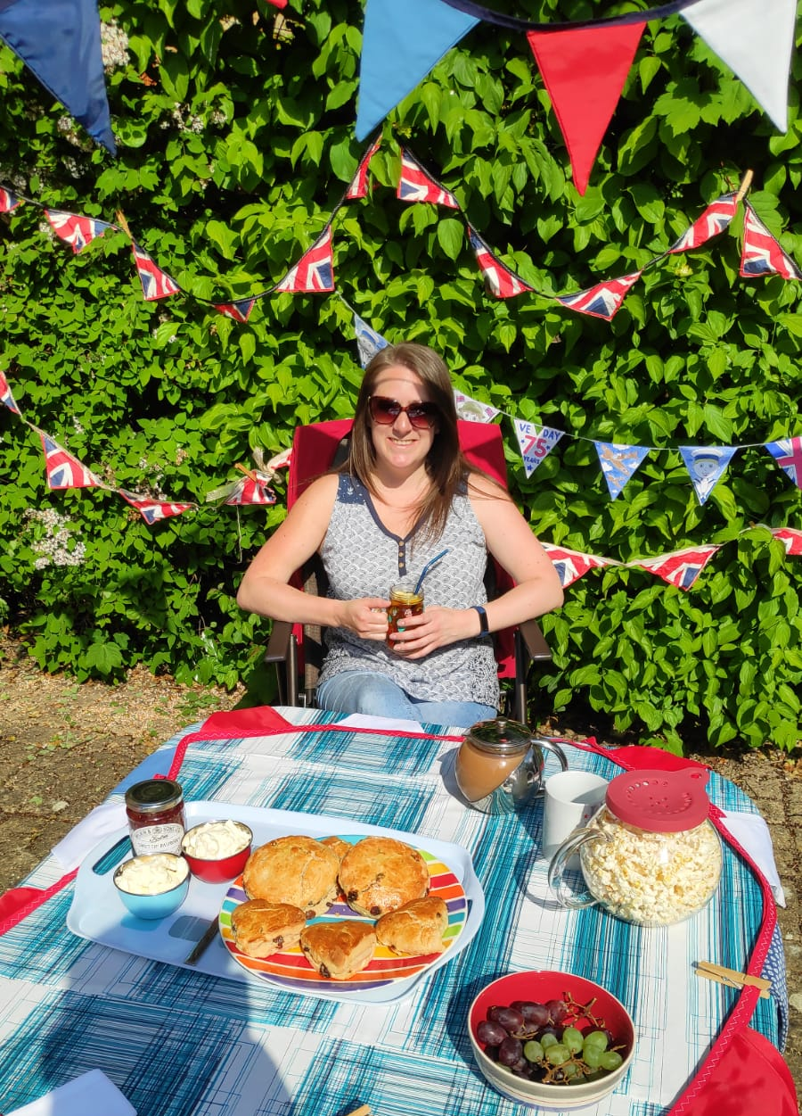
I’ve seen some fabulous photos of your VE day celebrations. I made some red, white and blue bunting and decorations, and baked some scones. They were rather delicious with jam and cream. Some people living near me sat in their gardens so we could try to celebrate together. I also had a video call with my family and enjoyed seeing the decorations and tasty treats they had made.
It’s been lovely to welcome back the sun this week and spend more time in the garden again. Some of my plants have been growing so much I needed to do some pruning to make them neater again. My neighbour has been doing lots of digging to create a whole new flowerbed. We’ve had some conversations over the fence about different flowers she might include.
After the fun of the Book Trust’s pyjamas day last Friday, I’ve had some snuggly evenings this week watching DVDs and films in my pyjamas before bedtime. I’ve watched some films of stories where I’ve read the book so I know the storyline. Then I played spot the difference to find parts that have been changed.
We really do love to see and hear about what you have been doing at home. Please try to email at least once a week to keep us updated homelearning@st-edmunds.suffolk.sch.uk
Have a good week and stay safe. I’m missing you all.
Love from Miss Eden

