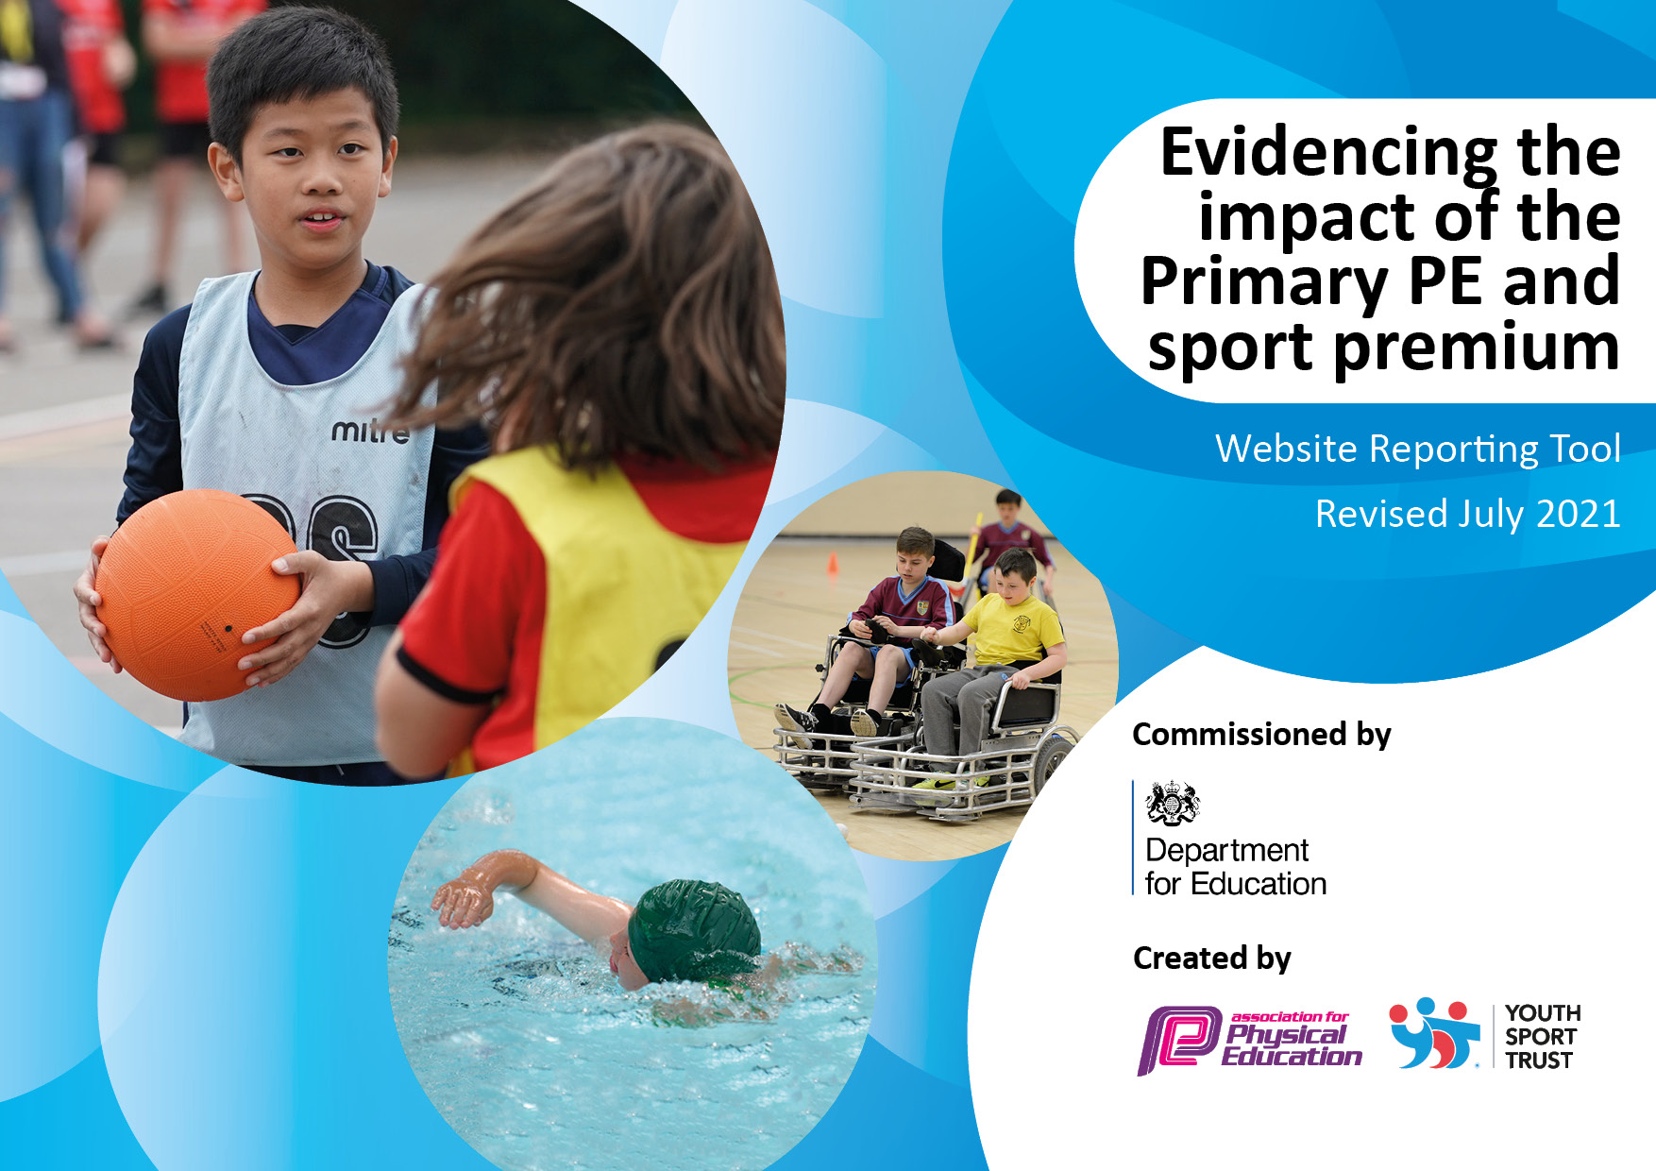
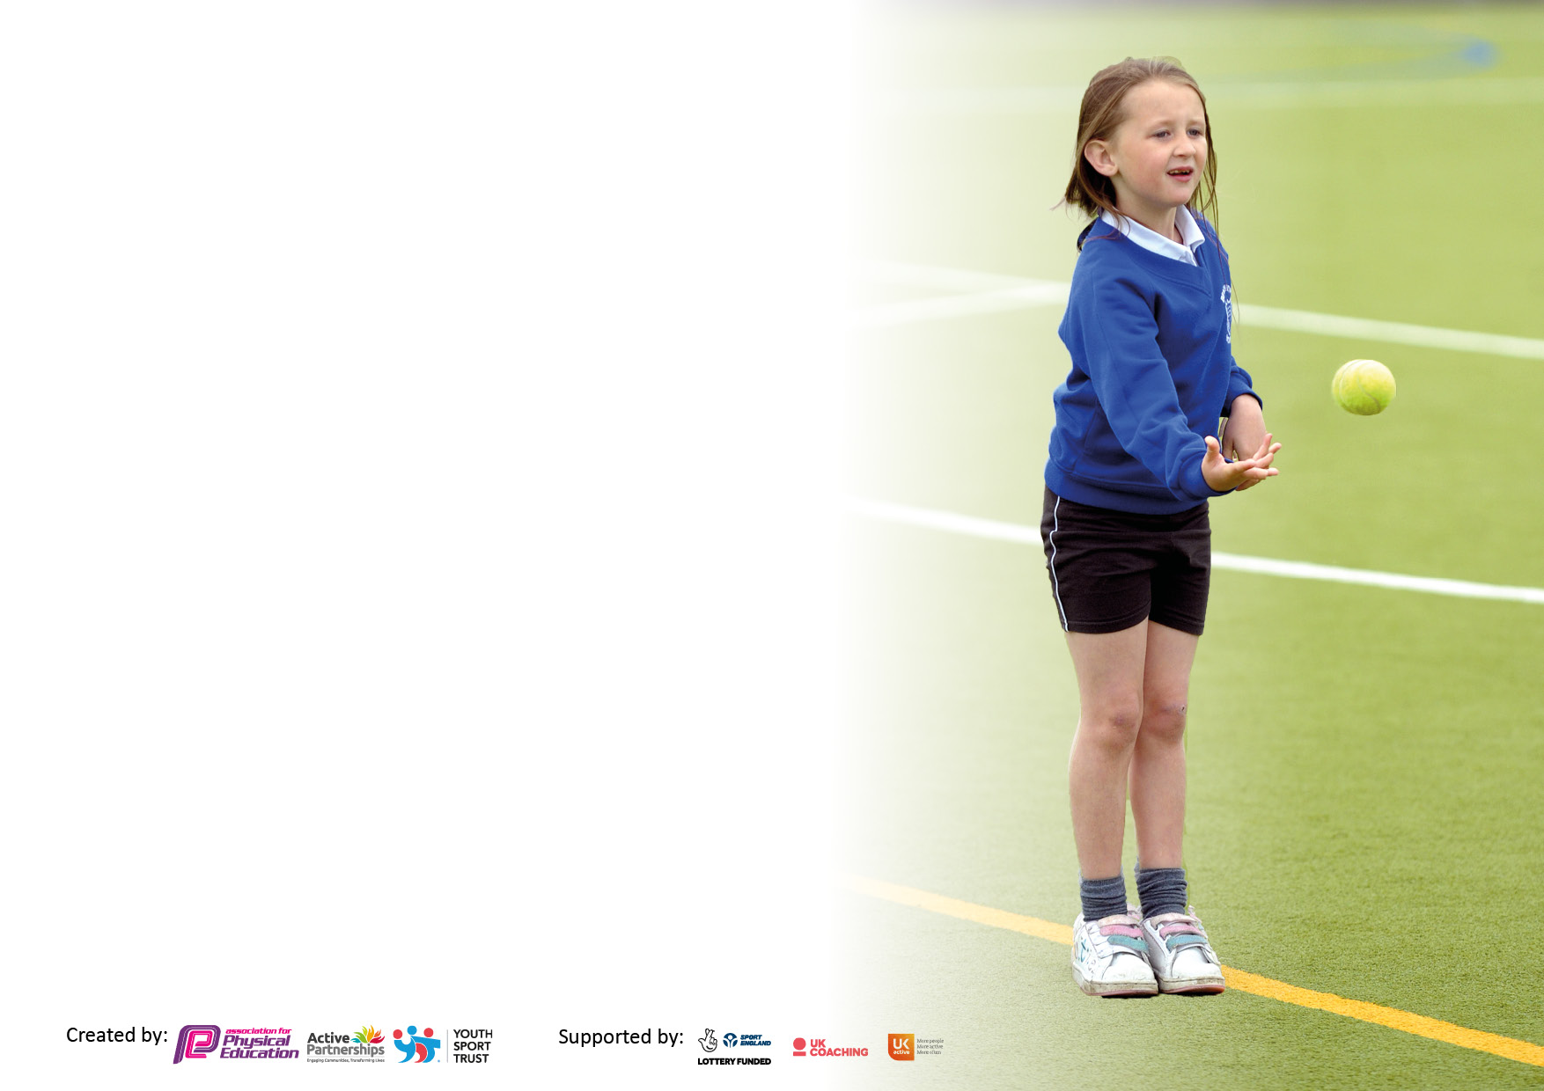

It is important that your grant is used effectively and based on school need. The Education Inspection Framework makes clear there will be a focus on ‘whether leaders and those responsible for governors all understand their respective roles and perform these in a way that enhances the effectiveness of the school’.

Under the Quality of Education Ofsted inspectors consider:
Intent - Curriculum design, coverage and appropriateness
Implementation - Curriculum delivery, Teaching (pedagogy) and Assessment
Impact - Attainment and progress

To assist schools with common transferable language this template has been developed to utilise the same three headings which should make your plans easily transferable between working documents.

Schools must use the funding to make additional and sustainable improvements to the quality of Physical Education, School Sport and Physical Activity (PESSPA) they offer. This means that you should use the Primary PE and sport premium to:

- Develop or add to the PESSPA activities that your school already offer
- Build capacity and capability within the school to ensure that improvements made now will benefit pupils joining the school in future years
- The Primary PE and sport premium should not be used to fund capital spend projects; the school’s budget should fund these.

Pleasevisitgov.ukfortherevisedDfEguidanceincludingthe5keyindicatorsacrosswhichschoolsshoulddemonstrate animprovement.Thisdocumentwillhelpyoutoreviewyourprovisionandtoreportyourspend.DfEencouragesschools to use this template as an effective way of meeting the reporting requirements of the Primary PE and sport premium.

We recommend you start by reflecting on the impact of current provision and reviewing the previous spend.

Schools are required to publish details of how they spend this funding, including any under-spend from 2019/2020, as well as on the impact it has on pupils’ PE and sport participation and attainment. All funding must be spent by 31st July 2022.

We recommend regularly updating the table and publishing it on your website throughout the year. This evidences your ongoing self-evaluation of how you are using the funding to secure maximum, sustainable impact. Final copy must be posted on your website by the end of the academic year and no later than the 31st July 2021. To see an example of how to complete the table please click HERE.

Details with regard to funding
Please complete the table below.

Total amount carried over from 2019/20 | £9,004
Total amount allocated for 2020/21 | £17,350
How much (if any) do you intend to carry over from this total fund into 2021/22? | £14,638
Total amount allocated for 2021/22 | £17,340
Total amount of funding for 2021/22. To be spent and reported on by 31st July 2022. | £31,978
Swimming Data
Please report on your Swimming Data below.

Meeting national curriculum requirements for swimming and water safety.

N.B. Complete this section to your best ability. For example you might have practised safe self-rescue techniques on dry land which you can then transfer to the pool when school swimming restarts.
Due to exceptional circumstances priority should be given to ensuring that pupils can perform safe self rescue even if they do not fully meet the first two requirements of the NC programme of study
What percentage of your current Year 6 cohort swim competently, confidently and proficiently over a distance of at least 25 metres?  N.B. Even though your pupils may swim in another year please report on their attainment on leaving primary school at the end of the summer term 2020.  Please see note above | 68%
What percentage of your current Year 6 cohort use a range of strokes effectively [for example, front crawl, backstroke and breaststroke]?  Please see note above | 58%
What percentage of your current Year 6 cohort perform safe self-rescue in different water-based situations? | 58%
Schools can choose to use the Primary PE and sport premium to provide additional provision for swimming but this must be for activity over and above the national curriculum requirements. Have you used it in this way? | Yes/No

Action Plan and Budget Tracking
Capture your intended annual spend against the 5 key indicators. Clarify the success criteria and evidence of impact that you intend to measure to evaluate for pupils today and for the future.
Academic Year: September 2020 to March 2021 - £17300 | Total fund carried over: £14638 | Date Updated:29/10/21
What Key indicator(s) are you going to focus on?  KI1- The engagement of all pupils in regular physical activity  KI4- Broader experience of a range of sports and activities offered to all pupils |  |  |  | Total Carry Over Funding:
 |  |  |  | £ 14638
Intent | Implementation |  | Impact
Your school focus should be clear how you want to impact on your pupils.  To invest in competitive sports clothing for the teams.  Improve / maintain the outdoor environment to increase the type of physical activity children can engage in | Make sure your actions to achieve are linked to your intentions:  Buy matching tracksuit trousers to the splash tops to ensure that the children are appropriately attired for winter matches.  Research suppliers. Meet with the school council and SLT to agree development. | Carry over funding allocated:  £750  13,888 | Staff are appropriately clothed to take part in sport when going to events / competing competitively.  Children have access to safe spaces to be active. Children and staff have safe spaces to be able to complete the curriculum. | Continue to monitor condition of sportswear and replace / buy new sizes as appropriate. Washing / drying facilities need to be improved.  Develop the outdoor areas further to engage children to be active.

Academic Year: 2021/22 | Total fund allocated: £17,340 | Date Updated: 29/10/21
Key indicator 1: The engagement of all pupils in regular physical activity – Chief Medical Officers guidelines recommend that primary school pupils undertake at least 30 minutes of physical activity a day in school |  |  |  | Percentage of total allocation:
 |  |  |  | 30%
Intent | Implementation |  | Impact
Your school focus should be clear what you want the pupils to know and be able to do and about  what they need to learn and to  consolidate through practice: | Make sure your actions to achieve are linked to your intentions: | Funding allocated: | Evidence of impact: what do pupils now know and what can they now do? What has changed?: | Sustainability and suggested next steps:
Outdoor Learning (specialist staffing)  More specific sporting opportunities at lunch times for children to be active across the age range during the year.  Develop ‘daily mile’ | To provide pupils with the opportunity to undertake a range of practical activities, in a physically active outdoor environment, helping to promote healthier lifestyles and develop team working skills.  Develop the long-term plan to ensure all children have access to regular provision. Keep a list of children that attend extra-curricular clubs to see who is accessing the offer.  Replenish lunch time equipment to give a variety of possible physical activities for all age ranges.  Repaint pitch lines / games on the playground  Track how far each class is doing and set targets for how far they need to get. Take part in virtual cross country in all classes. | Yes - £3,768  £500  £TBC approx. £1000  Subject leadership release time. | Utilising specialist staff has enabled staff to gain confidence in delivery of the forest schools. This is supporting our youngest children to learn how to be active and enjoy the outdoors in a safe way.  This has ensured that all children have access to age-appropriate equipment to maintain a healthy lifestyle. All children are active during breaktimes.  Due to site, management, this has yet to happen, as we are awaiting resurfacing before lining.  Children will be doing daily exercise to support the ’60 mins’ active daily pledge. | Develop the forest school area and curriculum, continuing to use specialist staff to upskill and train staff.  Use of play leaders and MDSA’s to ensure equipment is used purposefully.  To achieve this objective in the next calendar year.  Daily mile to be reviewed during the term, how often does it take place? How can we increase the participation? How can we allocate a space and time for this to happen / be more effective.
Key indicator 2: The profile of PESSPA being raised across the school as a tool for whole school improvement |  |  |  | Percentage of total allocation:
 |  |  |  | 20%
Intent | Implementation |  | Impact
Your school focus should be clear what you want the pupils to know and be able to do and about  what they need to learn and to  consolidate through practice: | Make sure your actions to achieve are linked to your intentions: | Funding allocated: | Evidence of impact: what do pupils now know and what can they now do? What has changed?: | Sustainability and suggested next steps:
Ensure the long-term plan and scheme of work in place is being used which ensures progression of key skills and sports across each of the key stages including EYFS.  Introduce assessment for PE across all year groups to ensure that childrens development is tracked across KS1 / KS2.  To replenish equipment / introduce new equipment so when children are undertaking physical activity, they have quality resources and will be engaged in their PE lessons. Introduce dodgeball (equipment and lesson plans) - 2nd most participated sport in the UK.  Ensure children who attend competitions and sports events are celebrated in assemblies, on whole school story and the school newsletter. | Monitor usage of the Cambridgeshire PE scheme and ensure all teachers have access / know how to use it.  Staff meeting to introduce the Cambridge PE Assessment tool.  Source cost of new equipment from suppliers and create a requisition form for Head to agree. Liaise with office to inform them of deliveries etc.  Develop storage of equipment to ensure resources kept in good condition.  Submit newsletter articles / match reports to the school website. | Subject leadership release time.  Subject leadership release time.  £3000  £500  Subject leadership release time. | This continues to be a work in progress. Tracking is in place for the Indoor Athletics units, and is allowing the opportunity for the children to compete against their own PB’s.  All children have access to age-appropriate equipment for PE lessons which is enabling staff to correctly teach the Cambridgeshire scheme.  The new storage facilities have enabled safe storage and easy access / use for the school sports leaders. Storage is ensuring the equipment is kept in better condition.  All sports teams are celebrated on twitter and in the school newsletter. | Have full tracking of PE across all year groups, aligned to the Cambridge PE scheme.  Ensure correct storage to reduce replacements costs which will enable a broader range of sports can be offered as new equipment for different sports can be bought.  Continue to monitor the storage areas to ensure that equipment is correctly stored to enable reduced spending on equipment in the future.  Engage with children who are competing outside of school and share their achievements as well.

Key indicator 3: Increased confidence, knowledge and skills of all staff in teaching PE and sport |  |  |  | Percentage of total allocation:
 |  |  |  | 20%
Intent | Implementation |  | Impact
Your school focus should be clear | Make sure your actions to | Funding | Evidence of impact: what do | Sustainability and suggested
what you want the pupils to know | achieve are linked to your | allocated: | pupils now know and what | next steps:
and be able to do and about | intentions: |  | can they now do? What has
what they need to learn and to |  |  | changed?:
consolidate through practice:
To increase the confidence, knowledge and skills of all staff teaching PE in key areas identified. | - Email questionnaire with deadline.  - Analyse questionnaire information.  - Arrange times to observe lessons with permission from head.  - Inform staff of observations and reason behind observation.  - Set observation format and share with staff.  - Contact various accredited providers to get prices, dates and course outcomes.  - Inform SLT of information and organise booking of most appropriate course for maximum impact. | Level 5 CT - £1125  Level 5 GB - £1125  + £400  Other training including NGB awards: £649 | The course is completed over two years and will enable better quality of PE lessons and greater understanding of the curriculum. | Gather staff views and provide training to address areas in which staff feel less confident.  Provide training for Staff and MDSA’S in order to help support staff members towards keeping children active / healthy.
Key indicator 4: Broader experience of a range of sports and activities offered to all pupils |  |  |  | Percentage of total allocation:
 |  |  |  | 15%
Intent | Implementation |  | Impact
Your school focus should be clear | Make sure your actions to | Funding | Evidence of impact: what do | Sustainability and suggested
what you want the pupils to know | achieve are linked to your | allocated: | pupils now know and what | next steps:
and be able to do and about | intentions: |  | can they now do? What has
what they need to learn and to |  |  | changed?:
consolidate through practice:
Develop the new long-term plan and scheme of work so a variety of sports are taught to all children as they progress through the school (introduce dodgeball / pop lacrosse).  To develop the forest school curriculum by purchasing equipment to extend the range of activities the children are exposed to.  Invest in outdoor table tennis tables and indoor table tennis tables (space dependent). | Share long term plan  Monitor how the long-term plan is being taught across the school. Lead session on the new sports so all staff are aware on how to deliver.  Liaise with the forest school / EYFS team. Parts of the forest school long term plan to be rewritten to include new activities.  Work with lunch time staff to ensure that the tables are being used and children are active. | Subject leadership release time.  £1500  £1400 | Dodgeball has been introduced and has been very successful and engaging all pupils to maintain a healthy lifestyle.  Improved development of the children’s fine and gross motor skills they require. These skills will impact on their ability to write with stamina and control. The extra skills in terms of perseverance, hand eye coordination, team building, self-expression and cardiovascular fitness will support development and help achieve the early learning goals.  Children are more active at breaktimes, and it is improving hand eye coordination. Children are enthused to be able to play another sport. | Continue to monitor the curriculum and identify other sports which can help children maintain a healthy active lifestyle.  Develop the forest school area and curriculum to support a broad and balanced curriculum  Run an afterschool club.

Key indicator 5: Increased participation in competitive sport |  |  |  | Percentage of total allocation:
 |  |  |  | 15%
Intent | Implementation |  | Impact
Your school focus should be clear | Make sure your actions to | Funding | Evidence of impact: what do | Sustainability and suggested
what you want the pupils to know | achieve are linked to your | allocated: | pupils now know and what | next steps:
and be able to do and about | intentions: |  | can they now do? What has
what they need to learn and to |  |  | changed?:
consolidate through practice:
To take part in school sports partnership competitions and School games competitions throughout the year.  To develop external competitions with other schools, making use of our facilities to host (netball court /field – U9 fixtures) | Keep registers of all children attending sports competitions so a wider spread of children are accessing opportunities- those with SEN, PP, EAL.  Introduce as many children as possible to competitive sporting situations across a variety of sports.  Work with the office to book coaches, cover staff, write risk assessments, write parental information letters and consents, log trips with evolve, track data of children that attend, share events for school community to raise profile.  Subject release time to attend competitions as well as for the hire of busses  Work with gymnastics coach so we can enter gymnastics competition.  Purchase additional gymnastics apparatus to enable participation | £1532  Subject leadership release time / £250 for specialist coaching  £1000 | Participation has increased in all areas and has enabled the school to maintain the platinum school games award.  Reintroduction of clubs post covid has been positive, with lots of children engaging in sports.  The number of pupils taking part in competitive sport will increase. This has been measured through the number of competitive sporting events participated in this year, as well as the number of pupils participating in these events.  The profile of School Sport has been raised by the school gaining entry to the national finals for dodgeball, as well as winning areas finals for football in Yr 3/4 and Yr 5/6.  Due to covid apparatus was not purchased as the gym competition was cancelled. | To continue to maintain registers for the sports clubs.  To offer increased range of clubs – investigate a basketball club.  Planning of how year groups can compete in interschool competitions.  Continued membership to the West Suffolk School Partnership, to arrange and compete in sporting events with other schools.  To complete this objective if the competition runs next academic year.

Signed off by
Head Teacher:
Date:
Subject Leader: | ALS
Date: | 7/7/22
Governor:
Date:

