ENGLISH – Character Description

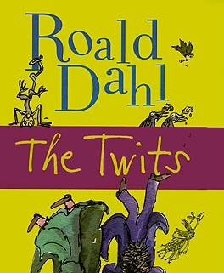
The Twits is a children's narrative by British author Roald Dahl (1979). The story is about a married couple known as the Twits, and the tricks they like to play on each other.
Mr. Twit is the main character and husband of Mrs. Twit. He has a beard he never washes because he believes it makes him appear "wise and grand", and has nothing better to do all day than play practical jokes and pranks on his wife (Dahl, Roald, 1979, p. 32).

Read the character description below, and by looking at Roald Dahl’s language, try to imagine the character in more depth from the information given.

Activity 1: Using the mind map below, write down how imagine Mr Twit would:

Appear Act
Mr. Twit

Sound Interact with
other characters

Activity 2: Use the template provided to create a ‘Prankster Wanted’ poster for display in our classroom. Be sure to include a short description of Mr Twitthat uses creative adjectives, nouns and verbs.

Mr Twit
Mr Twit was one of these very hairy-faced men. The whole of his face except for his forehead, his eyes and his nose was covered with thick hair. The stuff even sprouted in revolting tufts out of his nostrils and ear-holes.
Mr Twit felt that his hairiness made him look terrifically wise and grand. But in truth he was neither of these things. Mr Twit was a twit. He was born a twit. And not at the age of sixty, he was a bigger twit than ever.
The hair on Mr Twit’s face didn’t grow smooth and matted as it does on most hairy-faced men. It grew in spikes that stuck straight out like the bristles of a nail brush.
And how often did Mr Twit wash this bristly nailbrushy face of his?
The answer is NEVER, not even on Sundays.
He hadn’t washed it for years.
As you know, an ordinary unhairy face like yours or mine simply gets a bit smudgy if it is not washed often enough, and there’s nothing so awful about that.
But a hairy face is a very different matter. Things cling to hairs, especially food. Things like gravy go right in among the hairs and stay there. You and I can wipe our smooth faces with a flannel and we quickly look more or less alright again, but the hairy man cannot do that...
Mr Twit did not even bother to open his mouth when he ate. As a result (and because he never washed) there were always hundreds of bits of old breakfast and lunches and suppers sticking to the hairs around his face. They weren’t big bits mind you, because he used to wipe those off with the back of his hand or on his sleeve while he was eating. But if you look closely (not that you’d ever want to) you would see tiny little specks of dried-up scrambled eggs stuck to the hairs, and spinach and tomato ketchup and dried fish fingers and minced chicken livers and all the other disgusting things Mr Twit liked to eat...
Because of this Mr Twit never went hungry. By sticking out his tongue and curling it sideways to explore the hairy jungle around his mouth, he was always able to find a tasty morsel here and there to nibble on.
What I am trying to tell you is that Mr Twit was a foul and smelly old man.

