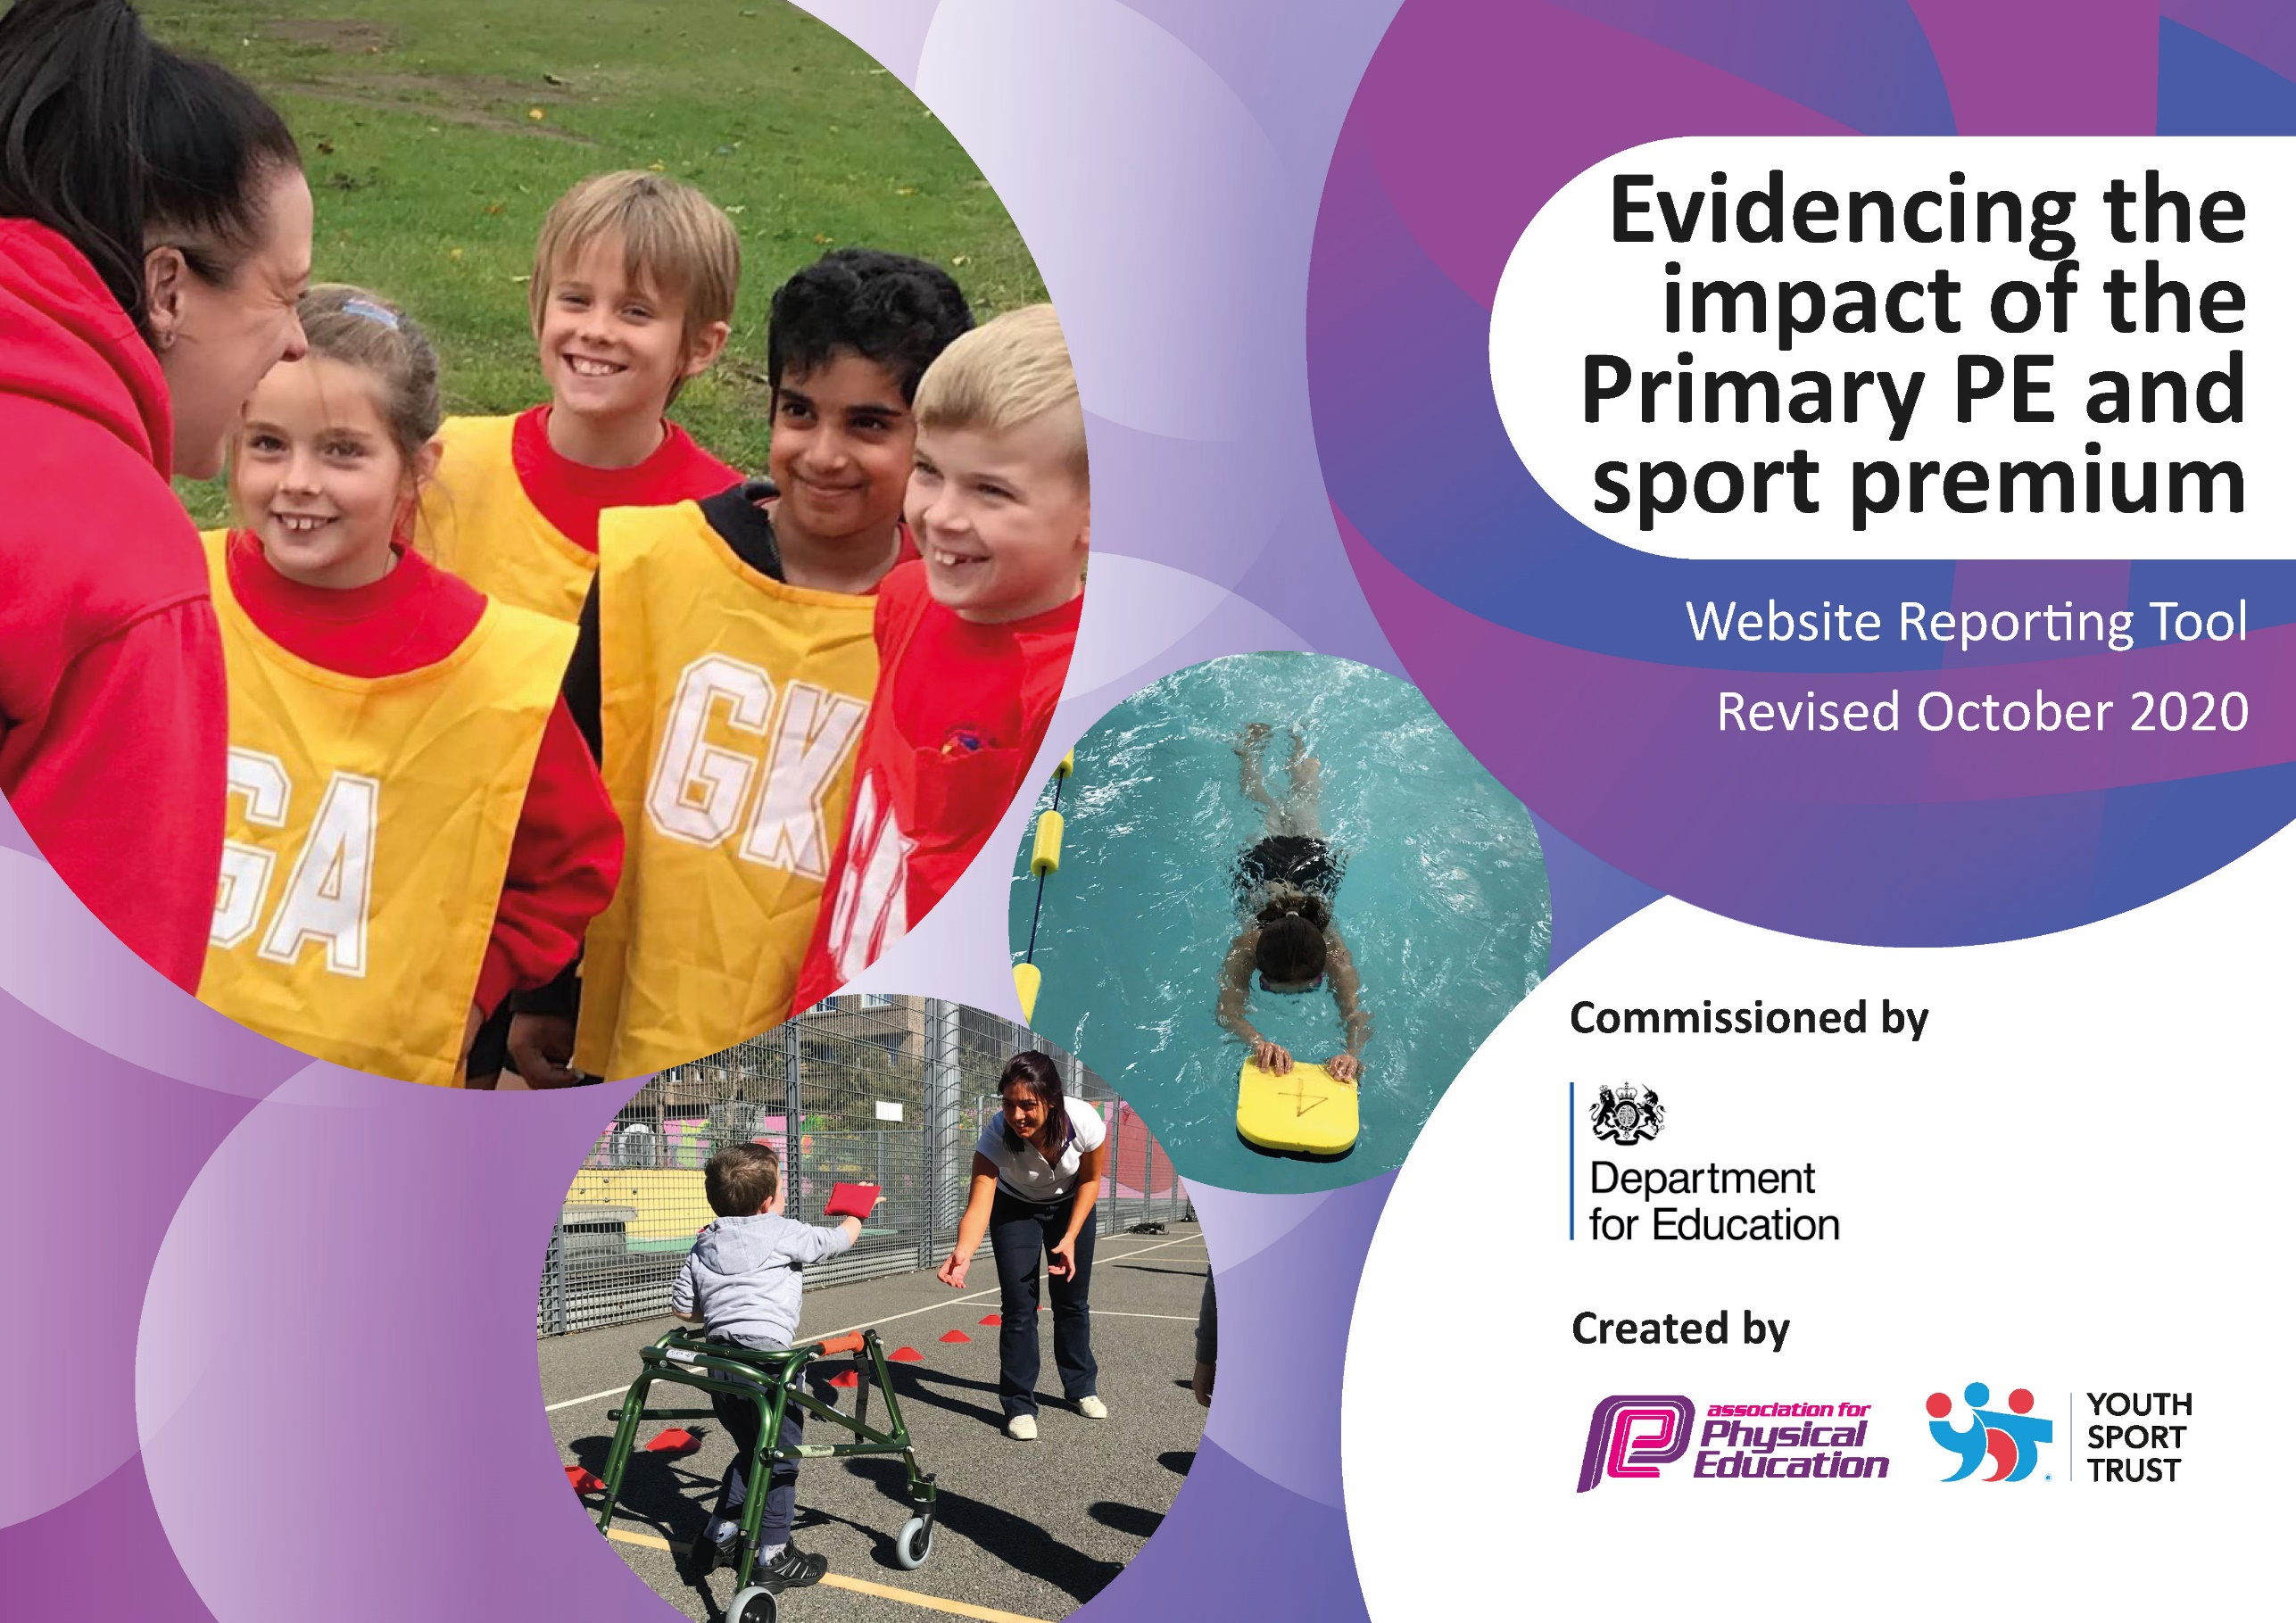
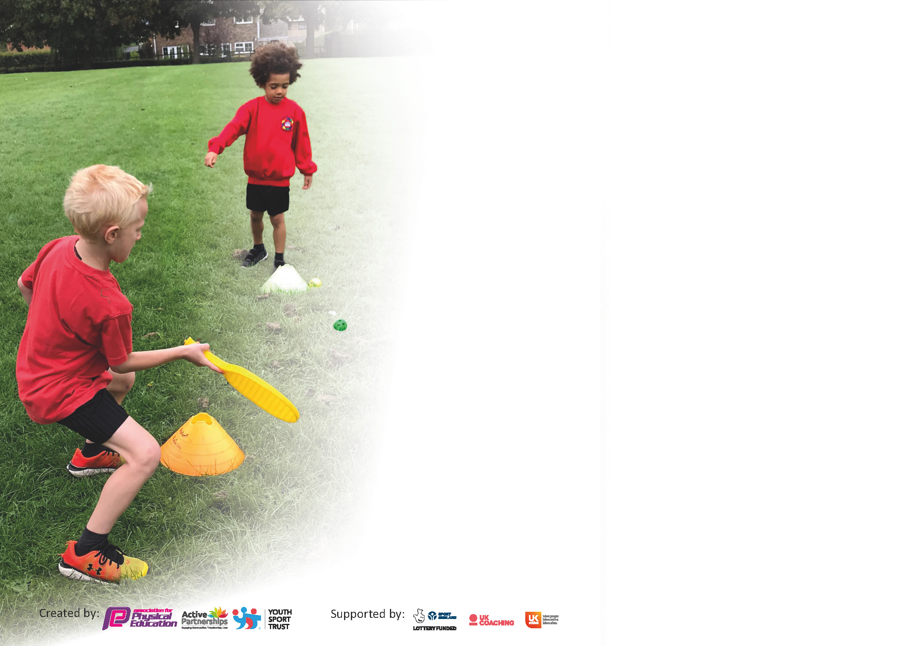

It is important that your grant is used effectively and based on school need. The Education Inspection Framework (Ofsted 2019 p64) makes clear there will be a focus on ‘whether leaders and those responsible for governors all understand their respective roles and perform these in a way that enhances the effectiveness of the school’.

Under the Quality of Education criteria (p41) inspectors consider the extent to which schools can articulate their curriculum (INTENT), construct their curriculum (IMPLEMENTATION) and demonstrate the outcomes which result (IMPACT).

To assist schools with common transferable language this template has been developed to utilise the same three headings which should make your plans easily transferable between working documents.

Schools must use the funding to make additional and sustainable improvements to the quality of Physical Education, School Sport and Physical Activity (PESSPA) they offer. This means that you should use
the Primary PE and sport premium to:

- Develop or add to the PESSPA activities that your school already offer
- Build capacity and capability within the school to ensure that improvements made now will benefit pupils joining the school in future years

Please visit gov.uk for the revised DfE guidance including the 5 key indicators across which schools should demonstrate an improvement. This document will help you to review your
provision and to report your spend. DfE encourages schools to use this template as an effective way of meeting the reporting requirements of the Primary PE and sport premium.

We recommend you start by reflecting on the impact of current provision and reviewing the previous spend.

Schools are required to publish details of how they spend this funding as well as on the impact it has on pupils’ PE and sport participation and attainment by the end of the summer term or by 31st July 2021 at the latest.

** In the case of any under-spend from 2019/20 which has been carried over this must be used and published by 31st March 2021.

We recommend regularly updating the table and publishing it on your website throughout the year. This evidences your ongoing self-evaluation of how you are using the funding to secure maximum, sustainable impact. Final copy must
be posted on your website by the end of the academic year and no later than the 31st July 2021. To see an example of how to complete the table please click HERE.
Created by: Supported by:

Please note: Although there has been considerable disruption in 2020 it is important that you publish details on your website of how you spend the funding - this is a legal requirement.
Support for review and reflection - considering the 5 key indicators from DfE, what development needs are a priority for your setting and your pupils now and why? Use the space below to reflect on previous spend and key achievements and areas for development.

N.B. In this section you should refer to any adjustments you might have made due to Covid-19 and how these will influence further improvement.
Key achievements to date until July 2020: | Areas for further improvement and baseline evidence of need:
KI1- The engagement of all pupils in regular physical activity  All pupils complete the daily mile. Children have access to a range of play equipment to encourage physical activity at lunch times and all children have access to 2 hours PE and Games a week in curriculum time.  KI2- The profile of PESSPA (PE, School sports and Physical activity) being raised across the school as a tool for whole school improvement  PE, school sport and physical activities were celebrated in school newsletters and Friday celebration assemblies. Match reports were also written by competing students.  KI3- Increased confidence, knowledge and skills of all staff in teaching PE and sport  Google Forms created to determine staff strengths and weaknesses, with training being delivered to address any areas in which staff feel less confident.  Staff have access to a comprehensive scheme of work to support knowledge when teaching PE and Games, which includes detailed lessons plans and diagrams to ensure consistency when teaching.  KI4- Broader experience of a range of sports and activities offered to all pupils  We have more provision of sports than before as part of an increase in the number of clubs available after school, with free sessions available to Pupil Premium children. This was done in collaboration with a local sports company who provided sports such as archery, fencing amongst several others. Children have access to different sporting opportunities during PE lessons led by class teachers.  KI5- Increased participation in competitive sport  Pupils were participating in more external events and we were on track to achieve the Silver Mark in the School Sports Mark, due to the Corona Virus epidemic, schools received their previous grading.  All children in Years 5 and 6 compete in a minimum of 1 Intra-house competitions per term, linked to the school games values. | KI1- The engagement of all pupils in regular physical activity  More specific sporting opportunities at lunch times for children to be active across the age range during the year. Use sports leaders to lead lunchtime clubs and games to increase participation in sports at lunch times.  KI2- The profile of PESSPA (PE, School sports and Physical activity) being raised across the school as a tool for whole school improvement  Develop PE policy that focuses on the importance of PESSPA.  Replacement of school equipment that has become damaged over time such as basketball hoops, football goals and tennis nets  Checking and replacing equipment in line with health and safety requirements.  Raise the profile of PE by ensuring all children follow the School Games values for showing improved skills, determination, sportsmanship and participation.  Resourcing for Covid-19 safe PE – allowing rotation and cleaning of equipment  .  KI3- Increased confidence, knowledge and skills of all staff in teaching PE and sport  Continue to monitor staff confidence when using the new PE scheme through the creation of a questionnaire. Monitor whether and when training is available to help staff feel more confident when teaching subjects such as gymnastics, dance and rugby.  KI4- Broader experience of a range of sports and activities offered to all pupils  Continuing working with local sports providers to ensure a wide range of sporting opportunities are provided to different age groups.  KI5- Increased participation in competitive sport  Keep registers of all children attending sports competitions so a wider spread of children are accessing opportunities including those with SEN, PP, EAL.  Continue to take part in school sports partnership events and school games events. To aim for a Silver Sports Mark.  Register with YST for accreditation.

Did you carry forward an underspend from 2019-20 academic year into the current academic year? YES Delete as applicable

If YES you must complete the following section
If NO, the following section is not applicable to you

If any funding from the academic year 2019/20 has been carried over you MUST complete the following section. Any carried over funding MUST be spent by 31 March 2021.
Academic Year: September 2020 to March 2021 | Total fund carried over: £4,975 | Date Updated:27/05/2021
What Key indicator(s) are you going to focus on? |  |  |  | Total Carry Over Funding:
 |  |  |  | £4,975
Intent | Implementation |  | Impact
Your school focus should be clear how you want to impact on your pupils.  For pupils to engage in at least 2 hours of PE over the course of a week – including Forest School | Make sure your actions to achieve are linked to your intentions: | Carry over funding allocated:  £4975 | Evidence of impact: How can you measure the impact on your pupils; you may have focussed on the difference that PE, SS & PA have made to pupils re-engagement with school. What has changed?: | Sustainability and suggested next steps and how does this link with the key indicators on which you are focussing this academic year?:

Meeting national curriculum requirements for swimming and water safety.

N.B Complete this section to your best ability. For example you might have practised safe self-rescue techniques on dry land.
What percentage of your current Year 6 cohort swim competently, confidently and proficiently over a distance of at least 25 metres?  N.B. Even though your pupils may swim in another year please report on their attainment on leaving primary school at the end of the summer term 2021. | 68%
What percentage of your current Year 6 cohort use a range of strokes effectively [for example, front crawl, backstroke and breaststroke]? | 64%
What percentage of your current Year 6 cohort perform safe self-rescue in different water-based situations? | 66%
Schools can choose to use the Primary PE and sport premium to provide additional provision for swimming but this must be for activity over and above the national curriculum requirements. Have you used it in this way? | Yes/No

Action Plan and Budget Tracking
Capture your intended annual spend against the 5 key indicators. Clarify the success criteria and evidence of impact that you intend to measure to evaluate for pupils today and for the future.

Academic Year: 2020/21 | Total fund allocated: £19350 | Date Updated:27/05/2021
Key indicator 1: The engagement of all pupils in regular physical activity – Chief Medical Officers guidelines recommend that primary school pupils undertake at least 30 minutes of physical activity a day in school |  |  |  | Percentage of total allocation:
 |  |  |  | %
Intent | Implementation |  | Impact
Your school focus should be clear what you want the pupils to know and be able to do and about  what they need to learn and to  consolidate through practice: | Make sure your actions to achieve are linked to your intentions: | Funding allocated: | Evidence of impact: what do pupils now know and what can they now do? What has changed?: | Sustainability and suggested next steps:
For pupils to engage in at least 2 hours of PE over the course of a week – including Forest School  Continue to develop the Daily Mile  For pupils to engage in a range of different exercises and types sports.  To provide sporting opportunities before, during and after school. | Pupils all engage in 2 hours of PE each week.  Create a system to track each classes daily mile. Make it fun and enjoyable for the children by tracking class distance over time.  Pupils are engaging in the daily mile, ensuring that they get a minimum of 10 minutes exercise each day.  Sports clubs provide access to sports before, during and after school as part of our provision. | £15,025 |  | 78%
Key indicator 2: The profile of PESSPA being raised across the school as a tool for whole school improvement |  |  |  | Percentage of total allocation:
 |  |  |  | %
Intent | Implementation |  | Impact
Your school focus should be clear what you want the pupils to know and be able to do and about  what they need to learn and to  consolidate through practice: | Make sure your actions to achieve are linked to your intentions: | Funding allocated: | Evidence of impact: what do pupils now know and what can they now do? What has changed?: | Sustainability and suggested next steps:
Ensure the long-term plan and scheme of work in place is being used which ensures progression of key skills and sports across each of the key stages including EYs.  To replenish equipment / introduce new equipment so when children are undertaking physical activity, they have quality resources and will be engaged in their PE lessons.  To raise awareness of the aim for PE, to ensure that staff are all striving to achieve a common goal – the sports mark together. | Monitor usage of the Cambridgeshire PE scheme and ensure all teachers have access / know how to use it.  Meet with Early Years to discuss provision of PE and how best to support PE in EY.  Develop and improve on the storage of Sports Equipment, to ensure it is kept in good condition and is sustainable.  Promote and highlight the importance of PE through the use of displays and celebration assemblies – linking this to our school’s learning characteristics.  Staff meeting to discuss what we are aiming to achieve and how each class teacher can contribute to the sports mark award. | £275 |  | 1.4%

Key indicator 3: Increased confidence, knowledge and skills of all staff in teaching PE and sport |  |  |  | Percentage of total allocation:
 |  |  |  | %
Intent | Implementation |  | Impact
Your school focus should be clear | Make sure your actions to | Funding | Evidence of impact: what do | Sustainability and suggested
what you want the pupils to know | achieve are linked to your | allocated: | pupils now know and what | next steps:
and be able to do and about | intentions: |  | can they now do? What has
what they need to learn and to |  |  | changed?:
consolidate through practice:
Monitor the effectiveness of the Cambridgeshire scheme of work.  Provide plans for subjects not on the scheme to enable teachers to deliver PE lessons confidently.  To increase staff awareness and confidence in unfamiliar sports through the use of a staff questionnaire. | To provide expert tuition to improve areas in which staff feel less confident.  Use staff questionnaire to address and areas in which staff feel training or guidance is required. | £200 |  | 1%
Key indicator 4: Broader experience of a range of sports and activities offered to all pupils |  |  |  | Percentage of total allocation:
 |  |  |  | %
Intent | Implementation |  | Impact
Your school focus should be clear | Make sure your actions to | Funding | Evidence of impact: what do | Sustainability and suggested
what you want the pupils to know | achieve are linked to your | allocated: | pupils now know and what | next steps:
and be able to do and about | intentions: |  | can they now do? What has
what they need to learn and to |  |  | changed?:
consolidate through practice:
Additional achievements:  To increase pupil participation in a range of different sporting events.  To provide sporting opportunities before, during and after school.  To continue to promote external sporting opportunities.  To provide and allow opportunities for a range of alternative sports to be played and offered. | A range of new sporting clubs and opportunities through PE lessons as well as external sport providers. Increased awareness and the chance to participate in sports such as:  Archery, Fencing, Hockey, Girls Football,  Access to clubs before, during and after school.  Celebrate PE through a “PE Week” in which pupils participate in a range of different sporting activities such as ultimate Frisbee and Tchoukball.

Key indicator 5: Increased participation in competitive sport |  |  |  | Percentage of total allocation:
 |  |  |  | %
Intent | Implementation |  | Impact
Your school focus should be clear | Make sure your actions to | Funding | Evidence of impact: what do | Sustainability and suggested
what you want the pupils to know | achieve are linked to your | allocated: | pupils now know and what | next steps:
and be able to do and about | intentions: |  | can they now do? What has
what they need to learn and to |  |  | changed?:
consolidate through practice:
To increase the amount of competitive sport carried out within the school (intra) and against other schools (inter)  Continue membership with Bury School Partnership organisation, to allow and facilitate competition against other schools within the local area. | Enter competitions, both inter and intra school, with an emphasis on intra school until inter school competitions are viable.  Compete in “Virtual School games” against other schools. An | £1000 |  | 5%

Signed off by
Head Teacher:
Date:
Subject Leader:
Date:
Governor:
Date:

