St Edmund’s & St Joseph’s Catholic Primary Schools
Week commencing: 6th July 2020 Class: Abraham
Learning Characteristic - Ambitious
Below are some suggestions for learning that your child can do at home this week. You can help keep your child in contact with the school via the email link shown at the end of this message. Your child may want to share their achievements with their teacher by photographing or scanning it and sending it via email. A teacher will reply with a comment about the work shared.
Please email any completed activities/work to: homelearning@st-edmunds.suffolk.sch.uk

Welcome to week 15 of Home Learning!!

We hope you have had a good week. It was wonderful to see 4NW at Forest Schools on Tuesday last week. You have all grown so much and it was lovely to hear about all the things you have been doing in lockdown. Mr Francis is looking forward to seeing 4F on 15th July.
Thank you to those of you who have sent in your Home Learning. All the teachers really enjoy seeing and reading your work.

Subject/ Theme | Learning ideas and activities
English  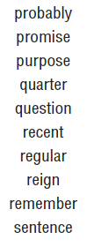 | Spellings:  This week we are focussing on some of the spellings from the end of the Year 3 /4 list.  The list is on the left here and this is the link to help you practise these words. Just click on spelling tiles and when you are ready take the test.  https://spellingframe.co.uk/spelling-rule/71/33-Word-list-years-3-and-4---pro--to-sen-  BBC BITESIZE - The new BBC Bitesize website offers lessons in English every day mainly focussing on grammar. It is also available on the red button on the BBC.  https://www.bbc.co.uk/bitesize/dailylessons  Reading:  See if you can get at least one quiz done this week – have that as your target.  Writing:  The English we have set will be for the next 2 weeks. It is based on Roald Dahl’s Revolting Rhymes. The Powerpoint, which is attached, gives a variety of activities for you to do as well as links to each Revolting Rhyme (slide 2).  You need to choose at least 1 activity each week.  If you would really like a challenge, maybe you could write your own Revolting Rhyme based on a story you know.  Have fun! Don’t forget to send them in so we can read them.
Maths  Again, well done to 4NW who won the battle this week! | White Rose Maths:  https://whiterosemaths.com/homelearning/year-4/  Year 4 Summer Term week 11.  This gives you a Maths lesson for each day this week - it's manageable and you can check to see how you're doing. By following these lessons, it means your child’s maths learning is exactly where it should be as this is the scheme we follow in school.  Watch the PowerPoint presentation first and then have a go at the activities.  TT Rock Stars: Keep on practising on studio and garage! This week we want everyone to do a soundcheck to see how many you can get correct out of 25. Please make sure you do this.  Mathletics: Continue to work through the activities we have set for you on Mathletics.  
Thrive/PSHE Activities | Why not put together your very own happiness box? You could decorate a box and put inside some of the things that make you happy. This could include photographs, objects and pictures.  Don’t forget there are also other Thrive activities you could do on the attached sheet.
Science | Next week is Science week on BBC Bitesize. Have fun and let us know what you get up to.  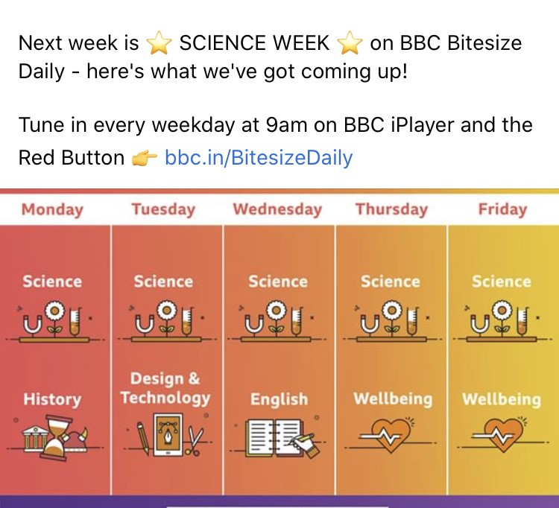
Physical Education | The Wimbledon tennis tournament was meant to begin last week. For the next week, we have found the LTA Youth Home Tennis training activities that would be good for you to do at home. These are set for ages 4-7 years and 8-11 years.  Please see link below and don’t forget to send some pictures in.  Now more parks and open spaces are accessible you could go and practise your skills.  https://www.lta.org.uk/tennis-at-home
RE/RRS (Rights Respecting Schools) | This week our RE is all about St. (Mother) Teresa of Calcutta. At this time of year our RE focus is on the Church in action and she is such an inspiration. You will find some resources added on our Home Learning page. There is a Powerpoint about St. Teresa of Calcutta and a timeline activity to complete  For Rights Respecting Schools, the Article of the week is 17 about reliable information.  Here's the link: https://stedmundsandstjosephs.sharepoint.com/staff/Shared%20Documents?id=%2Fstaff%2FShared%20Documents%2FSubject%20Leaders%2FSt%20Edmunds%2FRRS%2FResources%20for%20teaching%20and%20learning%2FRights%20Power%20Points&viewid=993ed159%2Dcee1%2D498d%2Daffd%2Da0971c560a07
French | “CRACK THE CODE” NUMBER WORK ACTIVITY.  Utilisez le code et les nombres en français pour découvrir des faits intéressants sur la France.  Use the code and your number knowledge to find out interesting facts about France.  You'll find the coded message on the PDF document on our home learning page.  Bonne chance!
Art | Children’s Art Week continues this week. Some of you have already begun to develop your drawing skills, well done!  If you haven’t had the chance yet, here is a link to a the brilliant illustrator Rob Biddulph (children's author and illustrator).  He is continuing to do a session called 'Draw with Rob' twice a week, which features him drawing a cartoon character. All previous clips are here:  http://www.robbiddulph.com/draw-with-rob  Just select a clip and off you go! The clips are about 15 minutes long and a nice pace to keep up with.  Everyone can have a go and you may be surprised at what you can achieve!!  Including the grown-ups!!!

