Monday 22nd June 2020
Hello everyone,
I hope you have a good week with your families. It was lovely to see so many of you at the virtual assemblies last week. I hope you liked the chick names, I thought they were all fantastic names. Well done if you sent a suggestion in too!
I know lots of you enjoyed the Rainbow story video last week, so this week we are going to try a Year 2 Google meet. It will be on Wednesday 24th June at 10am, please check your email for the link. It will be lovely to see you all.
Over Easter, we were due to go to Spain but unfortunately couldn’t go, so instead we had a Spanish day at home. It was such fun that last week we decided to have an India Day! We found out about India, made Diwali lamps and tea light holders and even did some counting (with the help of an online video). We made flags and had an Indian takeaway and dancing to finish the day. It is good to find out about different countries and the way other people live. I wonder if you can find out about some places in the world and even have your own themed day at home!
Here are a few photos for you to enjoy:
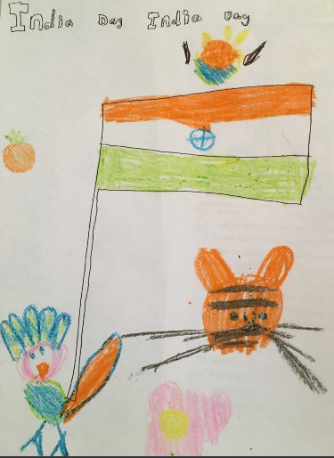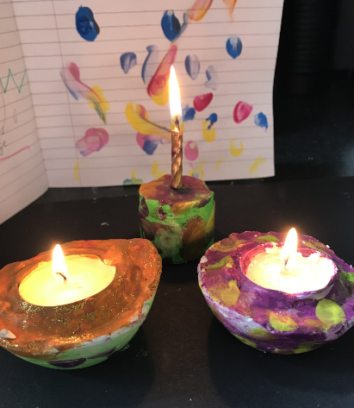
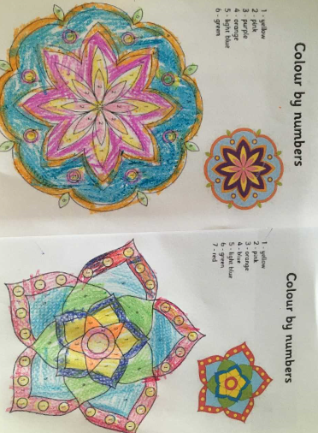
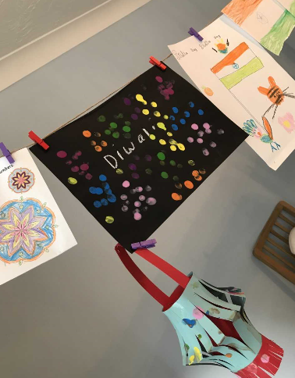

Take care everybody. Missing you all lots.

Hope to see you at the Google Meet.

Love from Mrs Martin

