St Edmund’s & St Joseph’s Catholic Primary Schools
Week commencing: 22nd June 2020 Year Group : Year 4
Learning Characteristic - Resourceful
Below are some suggestions for learning that your child can do at home this week. You can help keep your child in contact with the school via the email link shown at the end of this message. Your child may want to share their achievements with their teacher by photographing or scanning it and sending it via email. A teacher will reply with a comment about the work shared.
Please email any completed activities/work to: homelearning@st-edmunds.suffolk.sch.uk

Welcome to week 13 of Home Learning!!

We have enjoyed assemblies with Mrs Kemble on Monday and Friday again this week where we saw lots of children receiving the hands of success. But our highlight was our ‘Year 4 Get Together’ at 10.30am on Tuesday – so we have decided to make it a regular weekly slot! It has been wonderful to see so many faces

The meeting code for Google Meet is - pkk-iste-zsf
Subject/ Theme | Learning ideas and activities
English  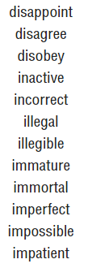  Prefixes List | Spellings:  This week we are going to focus on spelling prefixes. Prefixes are letters at the FRONT of a root word that changes the meaning of the root word. The prefixes are dis- , in- , il-, im-.  Practise these spellings by using the link below. This gives you sentences and games to play. Click on ‘Spelling tiles’ and ‘Practice/test’.  https://spellingframe.co.uk/spelling-rule/11/4-More-prefixes-1-of-3  BBC BITESIZE - The new BBC Bitesize website offers lessons in English every day mainly focussing on grammar. It is also available on the red button on the BBC.  https://www.bbc.co.uk/bitesize/dailylessons  Reading:  Keep doing those quizzes – we have been watching those wordcounts creeping up! A few more of you are close to becoming millionaires –keep going – nearly there!!  Writing :  This week we will be learning about The Amazon Rainforest. We would like you to put together an information sheet to tell us all about The Amazon Rainforest. You can include facts, a map, drawings, animals and lots more.  Attached is an information text checklist to remind you what you will need to include in your fact file.  Don’t forget to send these to our Home Learning so we can see all the hard work you have put into them.
Maths | White Rose Maths:  https://whiterosemaths.com/homelearning/year-4/  Year 4 Summer Term week 9.  This gives you a Maths lesson for each day this week - it's manageable and you can check to see how you're doing. By following these lessons, it means your child maths learning is exactly where it should be as this is the scheme we follow in school.  Watch the PowerPoint presentation first and then have a go at the activities.  TT Rock Stars: Keep on practising! This week we want everyone to do a soundcheck to see how many you can get correct out of 25. Please make sure you do this.  THIS WEEK WE HAVE SET UP A BATTLE – 4F against 4NW! It starts Thursday 18th June at 12 noon and finishes Thursday 25th June at 12 noon.  Mathletics : The Mathletics for next week is : Measurement : Length Converting cm and mm & cm and m.
Thrive/PSHE Activities | This week you could have a go at:  - Making your own musical instrument  - Make your own paintbrushes  - Play Twister  - Create a school map  OR choose something else from the attached sheet.
Geography | This week we will be focusing on The Amazon Rainforest. There is a lesson powerpoint attached and an information presentation giving you lots of facts. Read through this and have a go at the activities I have suggested.  - Locate where the Amazon Rainforest is on a map  - Draw a diagram to show the different layers of the Rainforest  - Draw and label a Rainforest animal.  - Make a model of The Amazon Rainforest
Physical Education | This week we thought we could try something different.  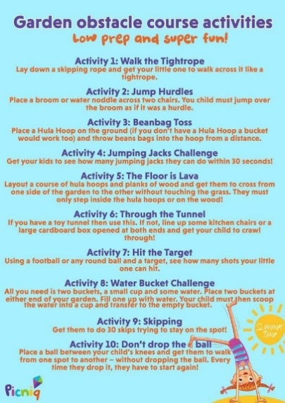  A copy of this is included in the attachments
Refugee Week | The Red Cross has released some resources for Refugee Week next week if you would like to use them.  The link is https://www.redcross.org.uk/get-involved/teaching-resources/refugee-week-imagine-a-kinder-world
RE | Friday 19 June was the Feast of The Sacred Heart of Jesus. Think about these questions -  - How important is your heart?  - How big do you think Jesus heart is?  - Could it fit the whole world in?  - How does it feel to know that Jesus forgives us no matter what we do? How great is that!!  Try drawing a heart and write a Thank You note on it to Jesus - how good does it feel knowing Jesus loves us always?
French | French Origami activity.  Choisissez une vidéo. Suivez les instructions pour créer une forme en origami.  (Select a videoclip. Follow the instructions to create one of the origami shapes. Look up the key words you don't understand in the “useful word” list on the PDF document on your yeargroup page.)  Vidéo 1: la grenouille. https://www.youtube.com/watch?v=lSLAo9IMHR4  Vidéo 2. le serpent (harder). https://www.youtube.com/watch?v=iiBqwkPJ6qA  Vidéo 3. l’étoile Ninja (much harder!!) . https://www.youtube.com/watch?v=dBytyDqIuTk  Amusez-vous bien! Have fun!
30 days wild!   | June is the month the Wildlife Trust launches its ‘30 days wild!’ programme – it is an annual nature challenge.  The link is included below for you to have a look at. There are so many exiting things to do especially now we can start to safely explore a little further outside. Cloud watching, bare feet walking and lots more!  https://www.wildlifetrusts.org/  There have been some great pictures of some of your adventures – keep sending them in!!
Music | Miss Eden has sent us the music for ‘All are Welcome’ for all you Year 4 musicians! We would love to see a video of you performing it sent through on the Home Learning email. It is on this weeks Home Learning page.

