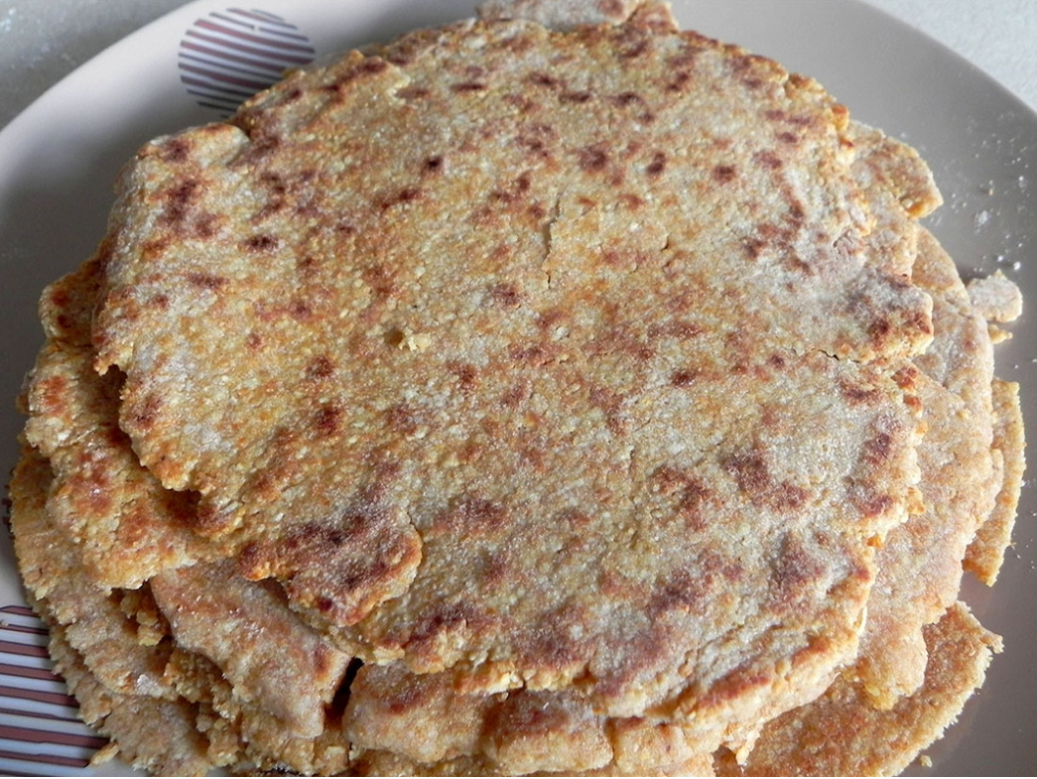
Ancient Roman Flat bread

Ingredients
- 500 g flour (400 g all purpose and 100 white)
- 1 tsp baking soda
- 1 tsp salt
- 4 tbsp melted lard (if you can’t get hold of lard, try butter or marg)
- 125-150 ml warm water

Instructions
- Put the flour, baking soda and salt in a blender.
- Pour the lard and a bit of water.
- Gradually add water until you get a thick dough.
- Knead it for 2-3 minutes until smooth. Place it in a bowl and cover with a towel. Let stand for 30 minutes.
- Roll out very thinly. Cut out circles with a diameter of 20 centimeters. Bake on both sides of a non-stick pan without oil.
- Serve hot with a slice of ham, salad, sausages or fresh soft cheeses.

Let us know how you got on!

