Monday 8th June 2020
Hello everyone,
How are you all? It was so lovely to see so many of you at the assemblies last week. It really put a smile on my face to see you all looking so happy!
I know it feels like such a long time since we have all been together, but meeting together helps us to remember that we are still learning together in God’s love and thinking of each other.
This week the year 2 teachers from both schools have made a video (you should see it at the top of the week 12 page). We thought it would be nice to read you a story and you could see us and hear our voices.
We would love it if you could let us know if you enjoyed the story or email any related work to homelearning@st-edmunds.suffolk.sch.uk. We always enjoy seeing your emails.
It was a little chillier last week but as I write this, the sun is shining and I hope it stays out as we are planning to have a BBQ later. During the week, I decided to make some family handprints. I thought you might like to see them. We each chose a colour and placed our painted hand on top of the other prints. I wonder if you can guess which colour mine is?
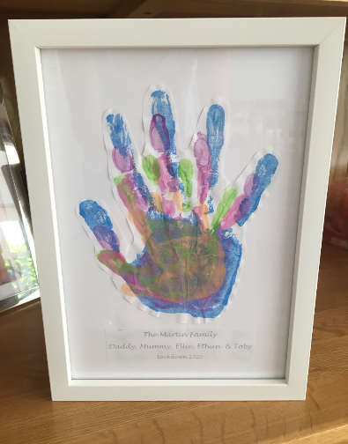
My little boy Ethan was very excited this morning as one of his top teeth fell out. It was a little wobbly already but after playing in the football in the garden and falling over a couple of times, it fell out! I wonder how many of you have lost a tooth recently. Year 1 and 2 seems to be the year of the missing front teeth!
Take care and I hope to see some of you at assembly this week.
Love from Mrs Martin

