St Edmund’s & St Joseph’s Catholic Primary Schools
Week commencing: 1.6.20 Year group: 1
Below are some suggestions for learning that your child can do at home this week. We understand that the situation is unprecedented, however we do recommend that the children stay in touch with their learning using the ideas given below. You can help keep your child in contact with the school via the email link shown at the end of this message. Your child may want to share their achievements with their teacher by photographing or scanning it and sending it via email. A teacher will reply with a comment about the work shared.
Please email any completed activities/work to: homelearning@st-edmunds.suffolk.sch.uk

Subject/ Theme | Learning ideas and activities
English  RE  THRIVE | Read the story ‘I want my hat back’ by Jon Klassen. You can listen to it using: https://www.youtube.com/watch?v=PdIDYvDP-oY  There is also a puppet version to watch – https://www.youtube.com/watchv=NBJmp1c3XIQ  Maybe you could make your own puppets to retell the story?  Can you find some different hats in your house? Choose one of them to help you make up your own story about some-one who has lost their hat.  The bear who has lost his hat needs to make a wanted poster. Can you help with some ideas – a description of the hat and where it was lost. (See ‘Missing poster’ in resources section.)  Can you find another story about a bear to read e.g. ‘We’re Going on a Bear Hunt’ or ‘Old Bear’ or ‘Paddington Bear?’  Practise reading and spelling HFWs  Spelling shed (St Joseph’s year 1 only) 10 mins practise a day  Scholastic Online Reading- please log on and read a book using your Reading Pro login details sent home via email last half term.. Don’t forget to complete your quiz at the end too!  Sunday 31st May is Pentecost Sunday. We remember when God sent the Holy Spirit to his disciples as tongues of fire. Listen to the story using https://www.youtube.com/watch?v=jNiApXVR9go You could write a prayer using the flame shape (resources) to ask the Holy Spirit for help with something.  The weekly Thrive document has lots of fun activities that you can do with your family and the people you live with.
Maths | Can you say the months of the year in order? Can you sing them using  https://www.youtube.com/watch?v=v608v42dKeI ? Can you conduct a survey and find out which month different members of your family celebrate their birthday?  Have a look at a clock. Can you find the face, the hands – short (hour) and long (minute?) Can you count around the clock in intervals of five minutes? Can you recognise when the clock is showing o’clock or half past? Can you use the worksheets (in resources) to draw the long and short hands to show these times?  You could make your own clock using the template or using paper plates and paper fasteners – (see resources.)  Mathletics activities (10 mins a day)  Times Table Rock Stars/ Numbots (10 mins day)
Science, History or Geography | Science - Food chains. Watch https://www.bbc.co.uk/bitesize/clips/z96r82p to learn more about food chains. Can you think of a different food chain? Look at the food web below to give you some ideas. Can you make a mobile with the predator at the top and the other animals and plants below? There is a food chain mobile to cut and make in the resources using a bluetit, caterpillars and leaves.  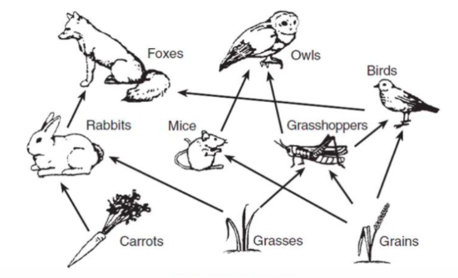  Science – 1st June sees the start of 30 days wild run by the ‘Wild Trusts.’ We have included a window poster to colour, a pack of ‘30 acts of wildness’ and a wall chart for you to record your activities. More to follow next week!  Geography – Can you use the cards to match the bears to the habitat? There are also some information cards about different types of bear. Once you have looked at these maybe you could use the world map to find whereabouts each bear is found.  History – What has President Theodore Roosevelt got to do with teddy bears? See if you can find out about this story  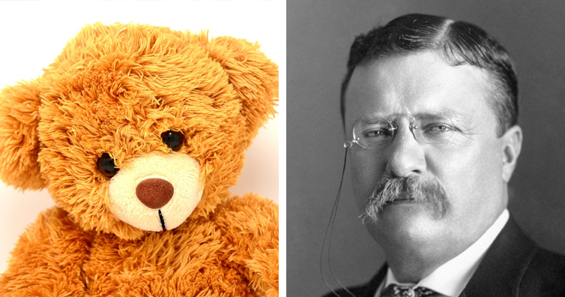
Physical Education | Pick one of these ideas to try for this week:  - Set up a newspaper relay race using a rolled-up newspaper instead of a baton  - Cosmic Kids Yoga (you tube)  - Joe Wickes PE  - Go Noodle (dance)
Arty crafty ideas | Pressing flowers - use the ideas in ‘Flower pressing’ (resources) to collect, press and make your own flower pictures.  Make a bear from a toilet roll. See this idea:  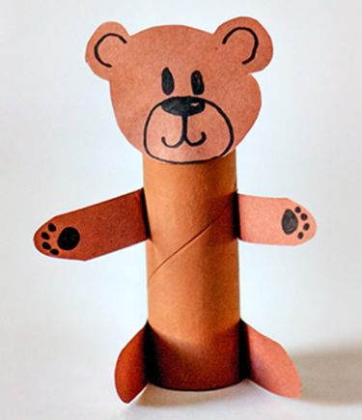  https://www.diythought.com/8-fun-bear-crafts-preschoolers-will-love/  You could also have a go at making an origami bear using this idea - 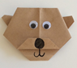 https://www.schoolmum.net/activity/craft/simple-origami-bear/
Music | Can you sing along with the song ‘Digging in the Garden’? Apologies as there was a technical hitch last week so this wasn’t available with the last home learning.  Research about your favourite music artist and make a poster about them  Listen to the piece of music ‘Fur Elise’ written by Beethoven. As you are listening – draw what you see:  https://www.youtube.com/watch?v=q5oSa4itomE  Don’t forget.... Young Voices at Home is happening THIS COMING WEEK! Simply register free using the link, learn the song ‘Power in Me’ and join in singing it on Tuesday 2nd June at 2.30!  If you are registered to take part you will receive a link on Monday 1st to the video you will need for your final performance on www.youngvoices.co.uk/powerinme The video will have exciting footage of people singing from around the world and will start with special warm ups from some amazing choir leaders including David Lawrence.  Wear something special and perform the song along with the video at home – you could even sing out of a window or outside so other people can hear. Don’t forget to let us all know how you get on - we would love to hear!

