Friday 27th March
Hello everyone! I hope that this finds you all well. I have really missed seeing you all. I know some of you have been doing Joe Wicks PE in the mornings – I have been joining in too with my children Lucy and Oscar which has been good fun, although my legs are a bit achy today! We have been taking our dog Luna for big walks in the afternoons too which she has loved. She is really enjoying extra cuddles from us at the moment!...
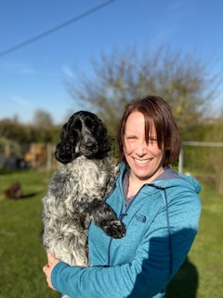
I have also been busy in the garden and have planted seeds that I hope will grow in the next few weeks. I’ll write again soon.
Love Mrs Mulligan x

