St Edmund’s & St Joseph’s Catholic Primary Schools
Week commencing: 6/4/2020 Year group: Noah
Below are some suggestions for learning that your child can do at home this week. We understand that the situation is unprecedented, however we do recommend that the children stay in touch with their learning using the ideas given below. You can help keep your child in contact with the school via the email link shown at the end of this message. Your child may want to share their achievements with their teacher by photographing or scanning it and sending it via email. A teacher will reply with a comment about the work shared.
Please email any completed activities/work to: homelearning@st-edmunds.suffolk.sch.uk

Subject/ Theme | Learning ideas and activities
English | - Please continue to practise your cursive handwriting.  - Continue to go through the Phase 2 and 3 sounds.  - Continue to practise reading the Phase 2 and 3 Tricky words. Then have a go at spelling them. (Google Phonics play, Alphablocks and Tricky word song)  - Read lots of books or let someone older than you read a book to you. Can you answer questions from the story or information book?  https://www.booktrust.org.uk/books-and-reading/have-some-fun/  - Write and send an Easter card to a relative you are unable to see at the moment.
Maths | - Please continue to practise writing your numerals.  - Watch Numberblocks or google Top Marks for maths games.  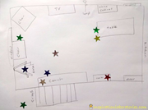  - Draw a map of your garden and design an Easter egg/bunny hunt with clues. These could be picture or word clues. Can you number your clues? How many steps can you count to each clue?  Can you count eggs or use them for simple addition and subtraction problems?
Science, History or Geography | 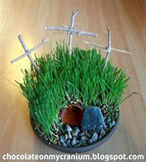  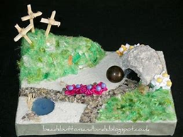  - Continue to find out about Good Friday and Easter Sunday. What happened? Can you retell the story. Could you make an Easter garden using items from your own garden and a tin tray?
Physical Education | - Follow Joe’s PE (The Body Coach) on Youtube, play in your garden (can you yo do the skipping challenge? How many skips can you do in a minute?), go for a walk with your family.
Arty crafty ideas | - Make Easter cards or Easter egg pictures.  - Continue with the Lego challenge.  - Do a puzzle.  - Play board games/card games/dominoes, etc.  - Make an Easter Bunny from Junk modelling (boxes from your recycling).  https://www.twinkl.co.uk/    Twinkl has hundreds of resources and it is free at the moment.

